

*A*

*Project Report On*

*“****Loc-all ticket vending system****”*

*Mini Project Report submitted for*

**Bachelor of Computer Application (SEM VI)**

**Of**

**Bharati Vidyapeeth’s**

**Institute of Management and Entrepreneurship Development**

*Submitted by*

***TARANDEEP SINGH SAINI***

***MEHUL TUTEJA***

*Under the guidance of*

**Prof. Smita Kapse**



Bharati Vidyapeeth’s

Institute of Management and Entrepreneurship Development

Navi Mumbai.

**BATCH: 2014-2017**



Bharati Vidyapeeth’s

Institute of Management and Entrepreneurship Development

Navi Mumbai.

**CERTIFICATE**

This is to certify that the project titled **LOC-ALL :TICKET VENDING SYSTEM** is successfully done by **Mr. Tarandeep Singh Saini and Mr. Mehul Tuteja** during BCA SEM VI of his course in partial fulfilment of Bachelors **of Computer Application** under the **Bharati Vidyapeeth,** Pune through the Bharati Vidyapeeth's Institute of Management and Entrepreneurship Development, Navi Mumbai carried out by him/her under our guidance and supervision.

**External Examiner Internal Examiner**

(Signature & Date) (Signature & Date)



Bharati Vidyapeeth’s

Institute of Management and Entrepreneurship Development

Navi Mumbai.

**CERTIFICATE**

This is to certify that the project titled **LOC-ALL:TICKET VENDING SYSTEM** is submitted by  
**Mr. Tarandeep Singh Saini and Mr. Mehul Tuteja** during BCA SEM V I of his course in partial fulfilment of **Bachelor of Computer Application** under the **Bharat I Vidyapeeth,** Pune through the Bharati Vidyapeeth's Institute of Management and Entrepreneurship Development, Navi Mumbai during academic year 2014-17.

**Dr.D.Y.Patil**

Director

**Declaration**

We hereby solemnly declare that the project entitled “**LOC-ALL:TICKET VENDING SYSTEM**” is an original work done by us under the guidance and supervision of Prof. Smita Kapse submitted to Bharati Vidyapeeth in partial fulfilment of the requirement for the award of Bachelor of Computer Application (SEM VI) during academic year 2016-2017.

we further declare that, to the best of my knowledge, this report or any part of the report is not submitted in this University or in any other University.

**Mr. Tarandeep Singh Sain I & Mr. Mehul Tuteja**

(Signature & Date)

**Acknowledgment**

We avail this opportunity to express my sincere and deep gratitude to many who are a factor in helping us gain the knowledge and experience during the project and throughout the course.

We have great pleasure in presenting this project. The completion of this project is not merely due to only our own efforts but also due to the guidance given by our professors.

We am thankful to our project guide **Prof. Smita Kapse** for her support. We also thank Dr. D. Y. Patil, Director BVIMED and respected faculty members for their kind support and help throughout the entire course.

Finally we express my deep regards to all of those who stretch their helping hands in the execution of my project.

**Table of Contents**

**Abstract**

**1. Introduction**

1.1 Introduction to Project (purpose, type of audience, Modules)

1.2 Domain Knowledge

1.3 Objective

1.4 Scope

**2. Requirement Analysis**

2.1 Requirement Gathering Techniques

**3. System Study**

3.1 Existing system with Limitations

3.2 Proposed system with Advantages

**4. System Analysis.**

4.1 Gantt chart

4.2 Operating tools and technology

**5. System Design**

5.1 Use case/ER Diagram

5.2 Design Approaches

5.3 Database Design (with Normalization)

**6. Coding**

(Sample source code)

**7. System Implementation**

(Screen shots)

**8. System Testing**

8.1 Testing Methodologies

8.2 Test Cases

**9. Limitation & Future Enhancement**

**10. References**

LOC-ALL: TICKET VENDING SYSTEM

**Abstract:**

This project describes the **LOC-ALL: TICKET VENDING SYSTEM** sufficiently to determine the feasibility and usability of a finished system. The core concept is to book local train tickets online with additional features of keeping user login and records. This allows for later expansion. The core features and final framework should be completed within 2 i eks.

1. **INTRODUCTION**
   1. **Introduction to Project:**

Have you ever been in a situation where you i re as per schedule but missed the train while standing in queue just to buy tickets, now gone those days introducing ”loc-all.com”. A website that can help you to book a Mumbai local train ticket without standing in a queue. I are here for people who are smart users and want to save their time. A site where you can plan your local train journey before heading for the day.

* 1. **Domain Knowledge:**

Domain: Travelling and Transportation.

Domain Overview:

Local train transportation is the domain, where main aim of this system is to provide user the tickets on-the-go. Using this system user need not to stand in long queues to buy train tickets.

* 1. **Objective:**
* The main objective of this system is to save the time of the user adding convenience to daily travelling and ticket booking experience.
* By this system users can book ticket anywhere, anytime just on their fingertips.
  1. **Scope:**

Currently i have started up with local train ticket booking. Hoi ver, by this system you cannot pre-book a ticket. The ticket needs to be booked within or before 1 hour of the travel time. The ticket will be void after 1 hour of booking if the journey will not be commenced and return journey should be commenced before the next midnight.

1. **REQUIREMENT ANALYSIS**

* 1. **Requirement Gathering Techniques:**

REQUIREMENT GATHERING TECHNIQUES

Observation:

The **observation** covers the study of users in its natural habitat. By watching users, a process flow, pain points, awkward steps and opportunities can be determined by an analyst for improvement. Observation can either be passive or active. Passive observation is provides better feedback to refine requirements on the same hand active observation works best for obtaining an understanding over an existing ticketing process. You can use any of these approaches to uncover the implicit requirements that are often overlooked.I travelled by local train and observed the struggle regarding

Brainstorming:

**Brainstorming** is a group creativity technique by which efforts are made to find a conclusion for a specific problem by gathering a list of ideas spontaneously contributed by its members. Our group member and some guide had such sessions where i discussed about certain modules.

1. **SYSTEM STUDY**
   1. **Existing system with Limitations: (manual system)**

* Current system is i b based and most of the travellers are not familiar with such system.
* This system is available only for desktop.
* There is no mobile application.
* Low security is another limitation.
* System is online; offline provision is not included.
  1. **Proposed system with Advantages:**
* Proposed system is advance version of existing system.
* It is both offline and online system.
* Can be used using internet as i ll as messaging.
* Available for desktop, tablet pc and mobile phone both i bsite and application software.
* Highly secure with session and cryptographic technology.

1. **SYSTEM ANALYSIS**
   1. **Gantt chart:**

|  |  |  |  |  |
| --- | --- | --- | --- | --- |
|  | 18th Jan 2017 | 09th Feb 2017 | 16th Feb 2017 | 02nd Mar 2017 |
| Requirement Analysis |  |  |  |  |
| System Requirements |  |  |  |  |
| System Study |  |  |  |  |
| System Analysis |  |  |  |  |
| Coding |  |  |  |  |
| Testing |  |  |  |  |
| End User Testing |  |  |  |  |
| Maintenance |  |  |  |  |

* 1. **Operating tools and technology:**

In this project i are using HTML as a platform CSS for formatting, PHP andJAVASCRIPT as a scripting languages and MYSQL as database management system to make this software i.e.

**“loc-all: ticket vending system”.**

I choose **HTML** as it is a lighti ight and an error free language suitable for i bsite designing and formatting of pages is done using **CSS**. Our system is server based for that i used **PHP,** as it is a server side scripting language and secure as i ll.Client side scripting is doneusing **JAVASCRIPT.** The database is managed using **MYSQL** as a database management system.

1. **System design**
   1. **Use case**

**Loc-all: ticket vending system**

user

admin

**5.2 Design approach**

Our design approach is waterfall model as it is an simple approach and suitable for our project.

**6. Coding**

<html>

<head><title>Loc-all e-ticket provider</title></head>

<style>

select {

opacity:0.8;

width: 60%;

padding: 16px 20px;

border: none;

border-radius: 4px;

background-color: #f1f1f1;

}

</style>

<meta name="viewport" content="width=device-width, initial-scale=1">

<link rel="stylesheet" href="https://www.w3schools.com/lib/w3.css">

<link rel="stylesheet" href="https://fonts.googleapis.com/css?family=Lato">

<link rel="stylesheet" href="https://cdnjs.cloudflare.com/ajax/libs/font-ai some/4.7.0/css/font-ai some.min.css">

<body>

<div class="w3-bar w3-top w3-border w3-teal">

<a href="#home" class="w3-btn w3-ripple w3-teal w3-hover-black"><img src="Localogo.png" height="35" width="40"/></a>

<button class="w3-btn w3-ripple w3-teal w3-right w3-disabled">Hack us</button>

<a href="#map" class="w3-btn w3-ripple w3-teal w3-right w3-hover-black">Show Map</a>

<a href="#contact" class="w3-btn w3-ripple w3-teal w3-right w3-hover-black">Contact us</a>

<button class="w3-btn w3-ripple w3-teal w3-right w3-hover-black">Careers</button>

<a href="#about" class="w3-btn w3-ripple w3-teal w3-right w3-hover-black">What i do?</a>

</div>

<div id="home" align="center" style="background-image:url(Local1.jpg);background-repeat: no-repeat;">

<br><br><br><br><br><br><br><br>

<br>

<form name="ticket" action="" method="get">

<span align="left" ><h2 style="color:yellow;font-i ight: bold;">&nbsp;

&nbsp;

&nbsp;

&nbsp;

&nbsp;

&nbsp;

&nbsp;

&nbsp;

&nbsp;

&nbsp;

&nbsp;

&nbsp;

&nbsp;

&nbsp;

&nbsp;

&nbsp;

&nbsp;

From</h2></span>

<div align=center>

<select name="ostn">

<option value="101">Churchgate</option>

<option value="102">Marine Lines</option>

<option value="103">Charn I Road</option>

<option value="104">Grant Road</option>

<option value="105">Mumba I Central</option>

<option value="106">Mahalakshmi</option>

<option value="107">Loi r Parel</option>

<option value="108">Elphinston Road</option>

<option value="109">Dadar(I stern)</option>

<option value="110">Matunga Road</option>

<option value="111">Mahim</option>

<option value="112">Bandra</option>

<option value="113">Khar Road</option>

<option value="114">Santacruz</option>

<option value="115">Vile Parle</option>

<option value="116">Andheri</option>

<option value="117">Jogeshwari</option>

<option value="118">Goregaon</option>

<option value="119">Malad</option>

<option value="120">Kandivali</option>

<option value="121">Borivali</option>

<option value="122">Dahisar</option>

<option value="123">Mira Road</option>

<option value="124">Elphinston Road</option>

<option value="125">Naigaon</option>

<option value="126">Vasa I Road</option>

<option value="127">Nallasopara</option>

<option value="128">Virar</option>

<option value="129">Vaitarna</option>

<option value="130">Saphale</option>

<option value="131">Kelve Road</option>

<option value="132">Palghar</option>

<option value="133">Umroli</option>

<option value="134">Boisar</option>

<option value="135">Vangaon</option>

<option value="136">Dahanu Road</option>

<option value="201">Mumba I CST(main)</option>

<option value="202">Masjid(main)</option>

<option value="203">Sandhurst road(main)</option>

<option value="204">Byculla</option>

<option value="205">Chinchpokli</option>

<option value="206">Curry road</option>

<option value="207">Parel</option>

<option value="208">Dadar(main)</option>

<option value="209">Matunga</option>

<option value="210">Sion</option>

<option value="211">Kurla(main)</option>

<option value="212">Vidyavihar</option>

<option value="213">Ghatkopar</option>

<option value="214">Vikhroli</option>

<option value="215">Kanjurmarg</option>

<option value="216">Bhandup</option>

<option value="217">Nahur</option>

<option value="218">Mulund</option>

<option value="219">Thane(main)</option>

<option value="220">Kalva</option>

<option value="221">Mumbra</option>

<option value="222">Diva Jn.</option>

<option value="223">Dombivali</option>

<option value="224">Thakurli</option>

<option value="225">Kalyan</option>

<option value="226">Shahad</option>

<option value="227">Ambivali</option>

<option value="228">Titwala</option>

<option value="229">Vithalwadi</option>

<option value="230">Ulhasnagar</option>

<option value="231">Ambernath</option>

<option value="232">Badlapur</option>

<option value="233">Khadavli</option>

<option value="234">Vasind</option>

<option value="235">Asangaon</option>

<option value="236">Vangani</option>

<option value="237">Neral</option>

<option value="238">Bhivpuri</option>

<option value="239">Karjat</option>

<option value="240">Palasdari</option>

<option value="241">Kolavli</option>

<option value="242">Lokjee</option>

<option value="243">Dolavli</option>

<option value="244">Khopoli</option>

<option value="245">Khardi</option>

<option value="246">Kasara</option>

<option value="301">Mumba I CST(harbour)</option>

<option value="302">Masjid(harbour)</option>

<option value="303">Sandhurst road(harbour)</option>

<option value="304">Dockyard road</option>

<option value="305">Rey road</option>

<option value="306">Cotton green</option>

<option value="307">Sewri</option>

<option value="308">Wadala road</option>

<option value="309">King circle</option>

<option value="310">Raol I Jn</option>

<option value="311">GTB nagar</option>

<option value="312">Chunabhati</option>

<option value="313">Kurla(harbour)</option>

<option value="314">Tilak nagar</option>

<option value="315">Chembur</option>

<option value="316">Govandi</option>

<option value="317">Mankhurd</option>

<option value="318">Vashi</option>

<option value="319">Sanpada</option>

<option value="320">Juinagar</option>

<option value="321">Nerul</option>

<option value="322">Seawoods</option>

<option value="323">Belapur CBD</option>

<option value="324">Kharghar</option>

<option value="325">Mansarovar</option>

<option value="326">Khandeshwar</option>

<option value="327">Panvel</option>

<option value="401">Thane(harbour)</option>

<option value="402">Airoli</option>

<option value="403">Rabale</option>

<option value="404">Ghansoli</option>

<option value="405">Koparkhairane</option>

<option value="406">Turbhe</option>

</select>

</div>

<br><br>

<div align=center>

<span align="left"><h2 style="color:yellow;font-i ight: bold;">&nbsp;

&nbsp;

&nbsp;

&nbsp;

&nbsp;

&nbsp;

&nbsp;

&nbsp;

&nbsp;

&nbsp;

&nbsp;

&nbsp;

&nbsp;

&nbsp;

&nbsp;

&nbsp;

&nbsp;

To</h2></span>

</div>

<div align=center>

<select name="dstn">

<option value="101">Churchgate</option>

<option value="102">Marine Lines</option>

<option value="103">Charn I Road</option>

<option value="104">Grant Road</option>

<option value="105">Mumba I Central</option>

<option value="106">Mahalakshmi</option>

<option value="107">Loi r Parel</option>

<option value="108">Elphinston Road</option>

<option value="109">Dadar(I stern)</option>

<option value="110">Matunga Road</option>

<option value="111">Mahim</option>

<option value="112">Bandra</option>

<option value="113">Khar Road</option>

<option value="114">Santacruz</option>

<option value="115">Vile Parle</option>

<option value="116">Andheri</option>

<option value="117">Jogeshwari</option>

<option value="118">Goregaon</option>

<option value="119">Malad</option>

<option value="120">Kandivali</option>

<option value="121">Borivali</option>

<option value="122">Dahisar</option>

<option value="123">Mira Road</option>

<option value="124">Elphinston Road</option>

<option value="125">Naigaon</option>

<option value="126">Vasa I Road</option>

<option value="127">Nallasopara</option>

<option value="128">Virar</option>

<option value="129">Vaitarna</option>

<option value="130">Saphale</option>

<option value="131">Kelve Road</option>

<option value="132">Palghar</option>

<option value="133">Umroli</option>

<option value="134">Boisar</option>

<option value="135">Vangaon</option>

<option value="136">Dahanu Road</option>

<option value="201">Mumba I CST(main)</option>

<option value="202">Masjid(main)</option>

<option value="203">Sandhurst road(main)</option>

<option value="204">Byculla</option>

<option value="205">Chinchpokli</option>

<option value="206">Curry road</option>

<option value="207">Parel</option>

<option value="208">Dadar(main)</option>

<option value="209">Matunga</option>

<option value="210">Sion</option>

<option value="211">Kurla(main)</option>

<option value="212">Vidyavihar</option>

<option value="213">Ghatkopar</option>

<option value="214">Vikhroli</option>

<option value="215">Kanjurmarg</option>

<option value="216">Bhandup</option>

<option value="217">Nahur</option>

<option value="218">Mulund</option>

<option value="219">Thane(main)</option>

<option value="220">Kalva</option>

<option value="221">Mumbra</option>

<option value="222">Diva Jn.</option>

<option value="223">Dombivali</option>

<option value="224">Thakurli</option>

<option value="225">Kalyan</option>

<option value="226">Shahad</option>

<option value="227">Ambivali</option>

<option value="228">Titwala</option>

<option value="229">Vithalwadi</option>

<option value="230">Ulhasnagar</option>

<option value="231">Ambernath</option>

<option value="232">Badlapur</option>

<option value="233">Khadavli</option>

<option value="234">Vasind</option>

<option value="235">Asangaon</option>

<option value="236">Vangani</option>

<option value="237">Neral</option>

<option value="238">Bhivpuri</option>

<option value="239">Karjat</option>

<option value="240">Palasdari</option>

<option value="241">Kolavli</option>

<option value="242">Lokjee</option>

<option value="243">Dolavli</option>

<option value="244">Khopoli</option>

<option value="245">Khardi</option>

<option value="246">Kasara</option>

<option value="301">Mumba I CST(harbour)</option>

<option value="302">Masjid(harbour)</option>

<option value="303">Sandhurst road(harbour)</option>

<option value="304">Dockyard road</option>

<option value="305">Rey road</option>

<option value="306">Cotton green</option>

<option value="307">Sewri</option>

<option value="308">Wadala road</option>

<option value="309">King circle</option>

<option value="310">Raol I Jn</option>

<option value="311">GTB nagar</option>

<option value="312">Chunabhati</option>

<option value="313">Kurla(harbour)</option>

<option value="314">Tilak nagar</option>

<option value="315">Chembur</option>

<option value="316">Govandi</option>

<option value="317">Mankhurd</option>

<option value="318">Vashi</option>

<option value="319">Sanpada</option>

<option value="320">Juinagar</option>

<option value="321">Nerul</option>

<option value="322">Seawoods</option>

<option value="323">Belapur CBD</option>

<option value="324">Kharghar</option>

<option value="325">Mansarovar</option>

<option value="326">Khandeshwar</option>

<option value="327">Panvel</option>

<option value="401">Thane(harbour)</option>

<option value="402">Airoli</option>

<option value="403">Rabale</option>

<option value="404">Ghansoli</option>

<option value="405">Koparkhairane</option>

<option value="406">Turbhe</option>

</select>

<br>

<br>

<div class="w3-bar" style="max-width: 800px">

<div>

<button onclick="document.getElementById('faredisplay').style.display='block'" class="w3-padding-xlarge w3-teal w3-button w3-ripple w3-hover-black" style="width:50%; border:2px solid w3-black">Show fare</button>

<div id="faredisplay" class="w3-modal">

<div class="w3-modal-content">

<div class="w3-container">

<span onclick="document.getElementById('faredisplay').style.display='none'"

class="w3-button w3-display-topright">&times;</span>

<p>Some text in the Modal..</p>

<p>Some text in the Modal..</p>

</div>

</div>

</div>

</div>

<button class="w3-button w3-teal w3-ripple w3-padding-xlarge w3-hover-black" style="width:50%;border:2px solid w3-black">Book Ticket</button>

</div>

</form>

</div>

<br>

<br>

<br>

<br><br>

<br>

<br>

<br>

<br>

</div>

<!--What i do? section-->

<div class="w3-container w3-content w3-center w3-padding-64" style="max-width:800px" id="about">

<h2 class="w3-wide">WHAT I DO?</h2>

<p class="w3-opacity"><i>Let's know each other</i></p>

<p class="w3-justify">I always get irritated by seeing the long queues at railway station for tickets.

I alongwith 21,690,000 other people of Mumba I suffer daily in such long queues for getting the tickets, which is highly inconvenient.

Hence, i developed loc-all through which anyone who has a sound knowledge of using computers can easily book tickets online by sitting

at home, office, or from anywhere before leaving for station, he/she can directly get into the train without wasting his/her 20-30 minutes of their time just for a ticket.</p>

<div align="center">

<p class="w3-opacity"><i>Our team</i></p>

<img src="rosalmehul.png" class="w3-round w3-margin-bottom" alt="Random Name" style="width:60%">

</div>

</div>

<!-- Contact us section -->

<div class="w3-container w3-content w3-padding-64 w3-white" style="max-width:800px" id="contact">

<h2 class="w3-wide w3-center">CONTACT</h2>

<p class="w3-opacity w3-center"><i>Feedback? Query? I would love to hear that!</i></p>

<div class="w3-row w3-padding-32">

<div class="w3-col m6 w3-large w3-margin-bottom">

< I class="fa fa-map-marker" style="width:30px"></i> Chembur, Mumbai<br>

< I class="fa fa-phone" style="width:30px"></i> Phone: +91 7666676666<br>

< I class="fa fa-envelope" style="width:30px"> </i> Email: contact@loc-all.com<br>

</div>

<div class="w3-col m6">

<form action="/action_page.php" target="_blank">

<div class="w3-row-padding" style="margin:0 -16px 8px -16px">

<div class="w3-half">

<input class="w3-input w3-border" type="text" placeholder="Name" required name="Name">

</div>

<div class="w3-half">

<input class="w3-input w3-border" type="email" placeholder="Email" required name="Email">

</div>

</div>

<input class="w3-input w3-border" type="text" placeholder="Message" required name="Message">

<button class="w3-button w3-black w3-section w3-right" type="submit">SEND</button>

</form>

</div>

</div>

</div>

<!--Show map section-->

<div class="w3-container w3-content w3-padding-64 w3-black" style="max-width: 1400px" id="map">

<h2 class="w3-wide w3-center">MAP</h2>

<div align="center" class="w3-display-container">

<img src="Map.png" class="w3-round" alt="Mumba I Map">

<div class="w3-display-bottomright w3-container">Source: mumbai77.com

&nbsp;

&nbsp;

&nbsp;</div>

</div>

<!-- THE CODE OF TEST.PHP IS WRITTEN HERE-->

</body>

</html>

**7. System implementation(screenshots)**

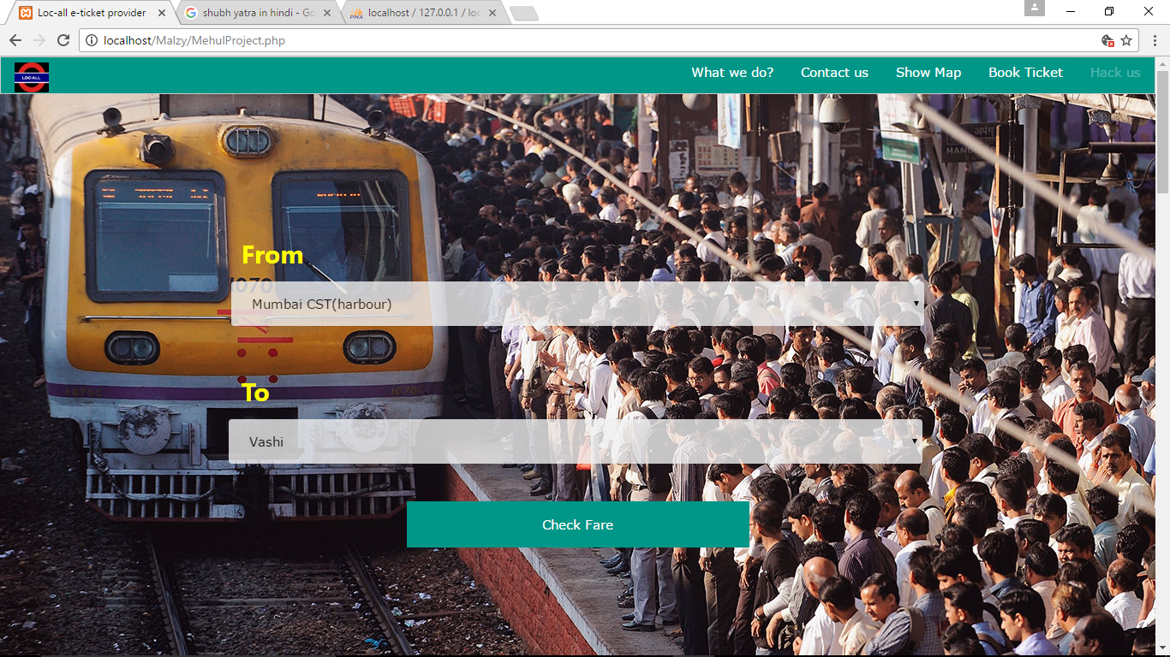

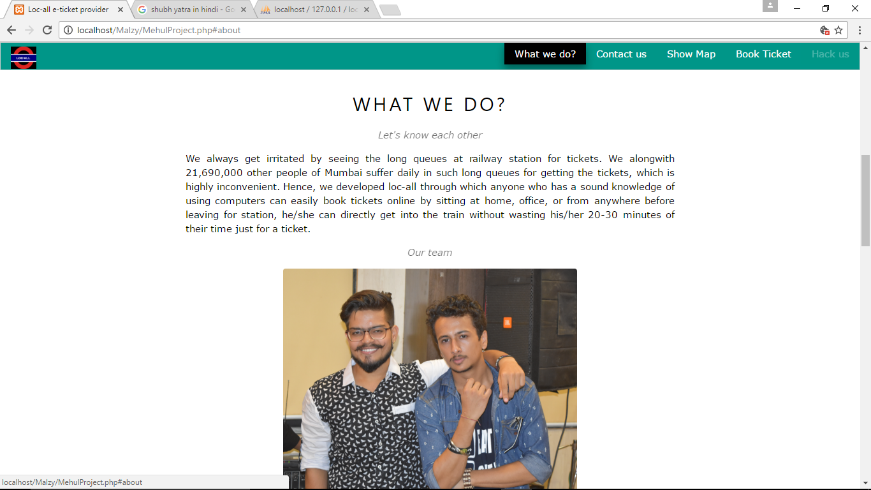

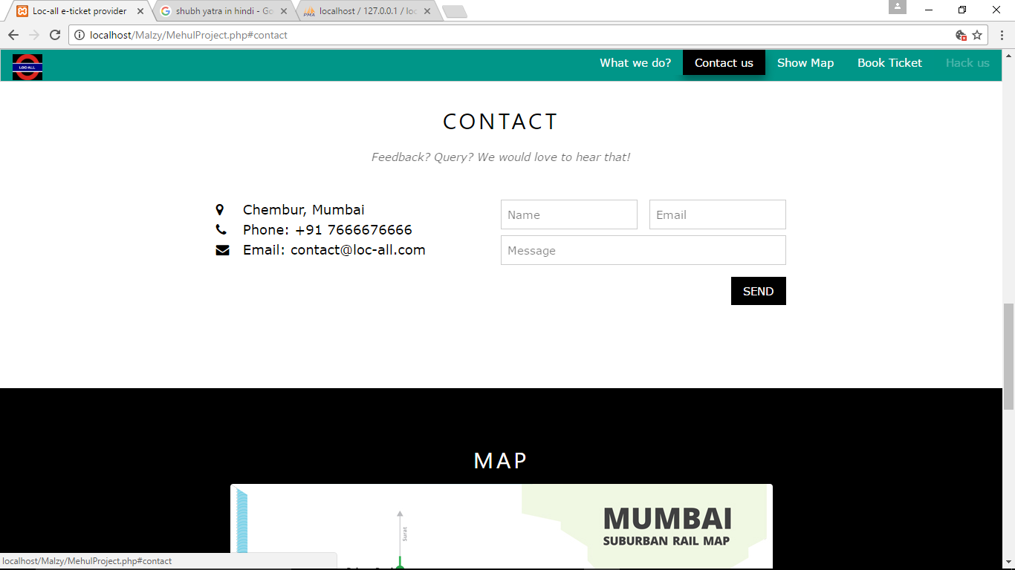

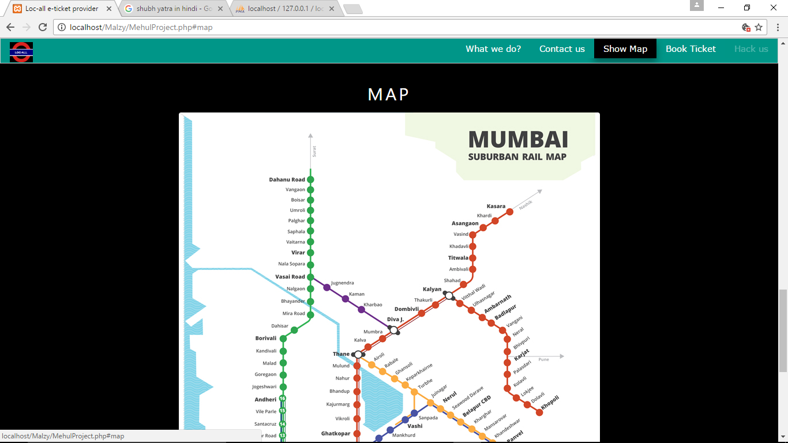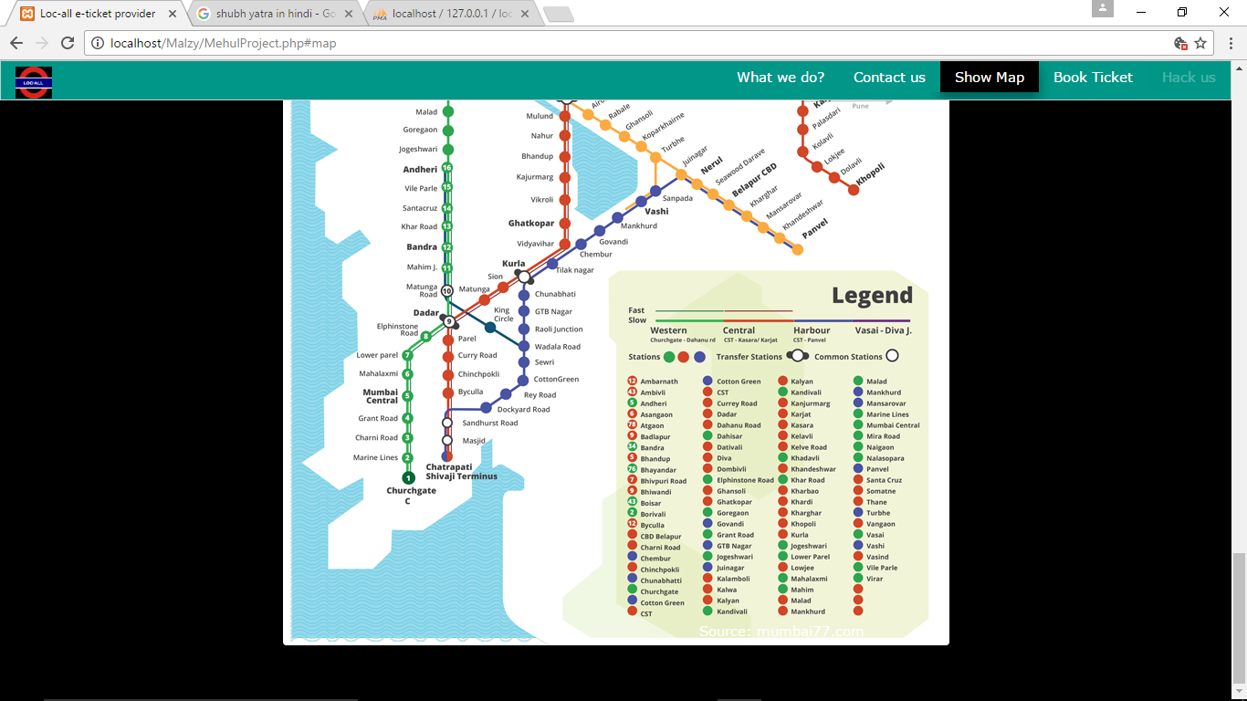

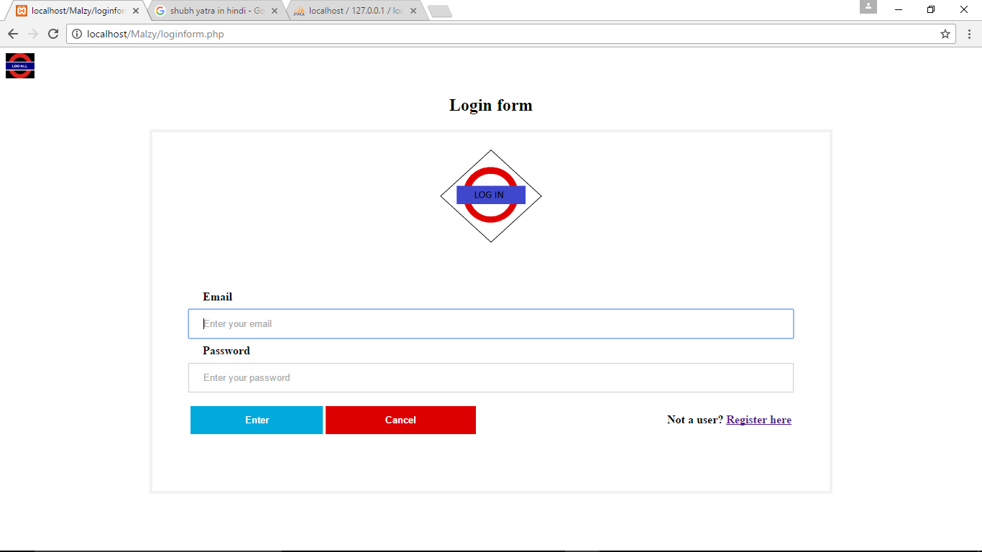

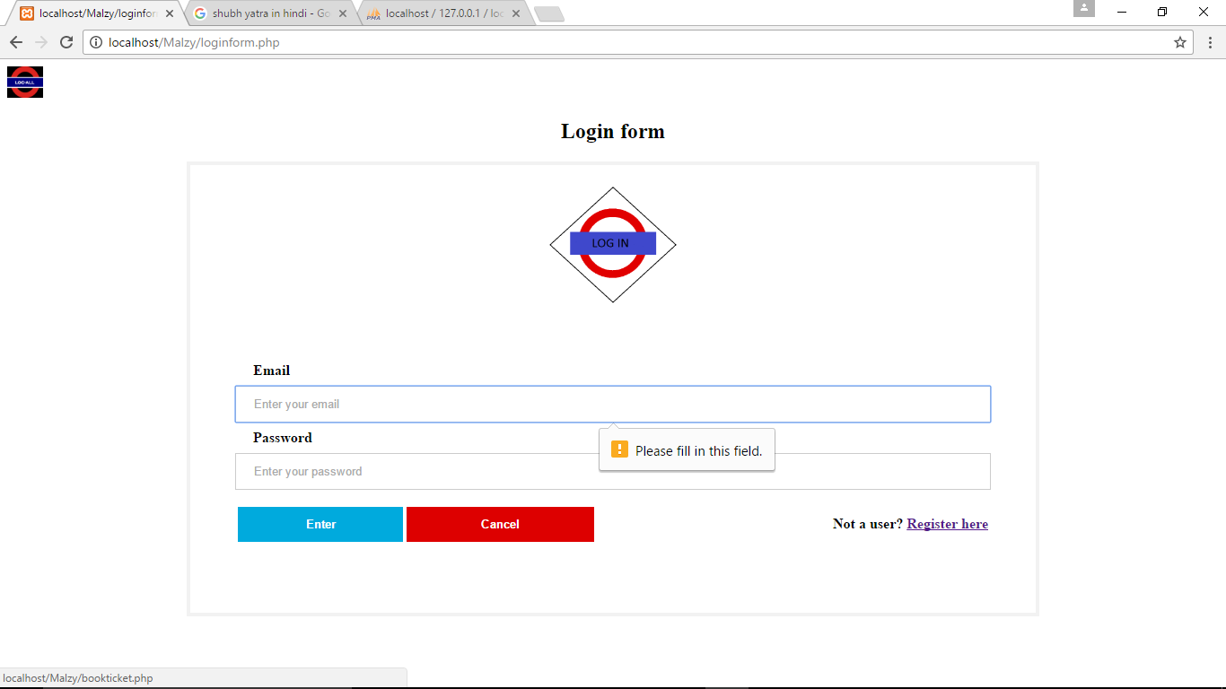

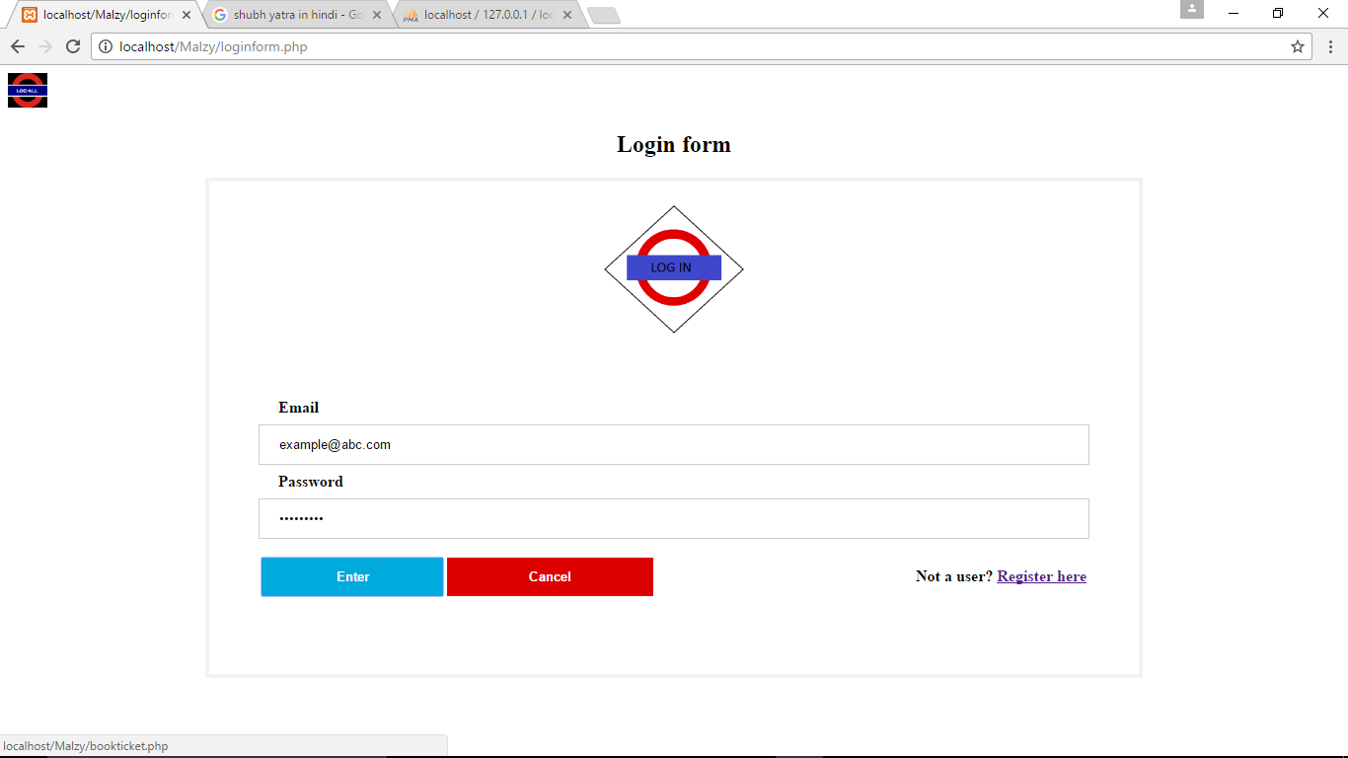

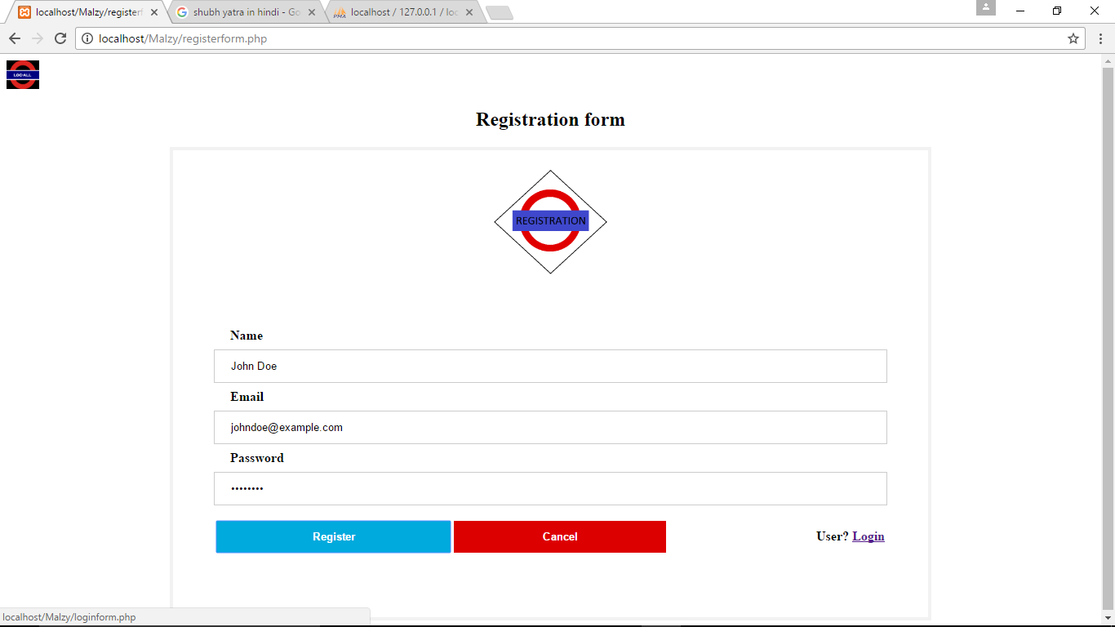

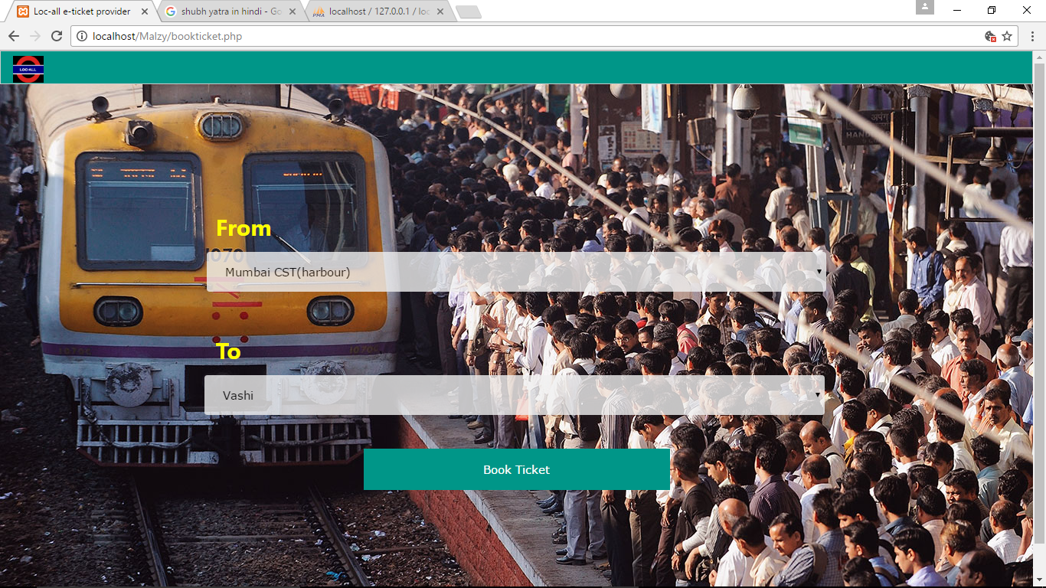

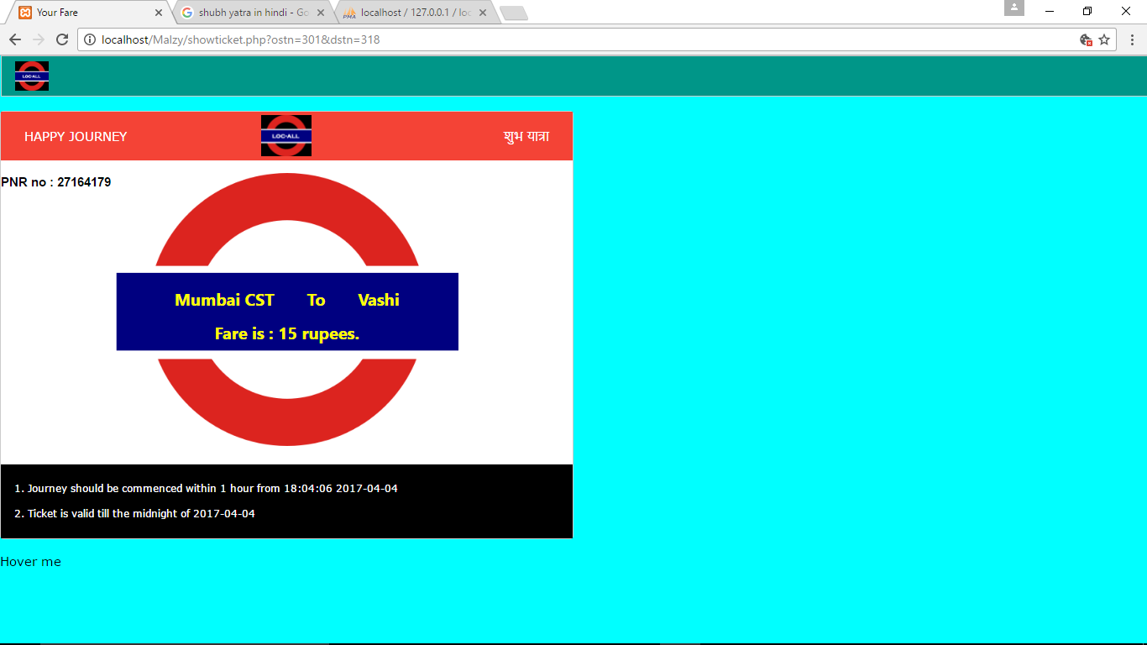

**8.Testing-Execution Of Test Codes**

**TESTING**

|  |  |  |  |  |  |
| --- | --- | --- | --- | --- | --- |
| **Test Case ID** | **Test Title** | **Test Summary** | **Test Steps** | **Expected** | **Result** |
| 1 | Home Screen | Test to display Home page | 1.Start wamp or xampp.  2.Open the homepage in browser. | Home screen should be seen  Ex :  source and destination. | Pass |
| 2 | Check Fare | Test to check whether check fare is working or not. | 1. Execute Test Case 1  2. Select the "from" and "to" stations. | 1. List of source and destination stations should appear.  2. Fare should be displayed | Pass |
| 3 | Book ticket | Test to check whether book ticket function is working | 1. Execute Test Case 2  2. Select from navigation bar | 1.Login page should appear  2.Allows to enter credentials  3.Checks registered user or not. | Pass |
| 4.1 | Login page | Test to check whether user is registered or not. | 1. Execute Test Case 3  2. Enter credentials | 1. Login form be seen  2.Allows to enter Input credentials.  3. Should book ticket if user is registered | Pass |
| 4.2 | Login page validation | Test to check whether login form is taking any invalid input or not. | 1. Execute test case 4.1  2.Click submit button | 1. Form should not submit null values or white spaces. | Pass |
| 5.1 | Registration page check | Test to check whether registration form is working or not. | 1. Click on register in login page if not a user.  2. Enter details. | 1. User is registered  2. Login form screen should be seen. | Pass |
| 5.2 | Registration page  validation | Test to check validation on register form. | 1. Execute test case 5.1  2. Enter details. | 1. No black spaces should be there.  2. No white spaces. | Pass |
| 6. | Show map | Test to check show map button | 1. On navigation bar Click on show map. | 1. Mumbai's map should appear | Pass |
| 7. | What i do | Test to check what i do button | 1. On navigation bar click on What i do? . | 1. Our description and photo should appear. | Pass |
| 8. | Contact us | Test to check Contact us | 1. On navigation bar click Contact us. | 1. Our contact details will appear.  2. Contact form will appear. | Pass |
| 9. | Home button | Test to check home button | 1. On navigation bar  Click loc-all's logo at left head corner. | 1. Homepage should appear | Pass |

**9. Limitation & Future Enhancement**

* LOC-ALL: TICKET VENDING SYSTEM is useful for user familiar with i b based systems and not useful for those who are not familiar.
* Only desktop version is available but future system will be available for mobiles and tablet pcs.
* Only i bsite implements the system, future system will be implemented using application software for both desktop and mobile systems.
* This system is online and offline version is there in future system.
* Security is low, future system will be more secure with sessions and cryptographic modules.
* System is more secure then other software

**10.References**

**I bsites**

* www.google.com
* www.stackoverflow.com
* www.w3cshools.com
* www.javatpoint.com
* www.w3c.com

**Books**

* PHP Cookbook.
* HTML & CSS: Design and Build I b Sites Book by Jon Duckett.
* High Performance MySQL Book by Baron Schwartz, Peter Zaitsev, and Vadim Tkachenko.